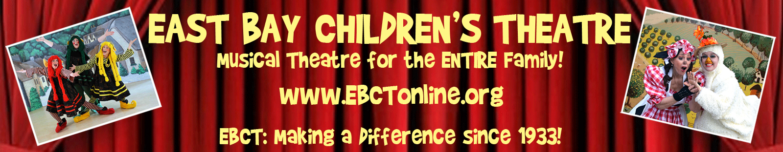

Contact:
ebctheatre@gmail.com

For Immediate Release
October 3, 2017

EAST BAY CHILDREN’S THEATRE ANNOUNCES AUDITIONS
Storied Troupe Celebrates 85 Years of Bringing FREE Theatre to School Kids

IT MUST BE PINOCCHIO!
The Wonderful-Funderful Family Musical
(With No Strings Attached)
To celebrate 85 historic years of bringing FREE musical theatre to under-served elementary school children, East Bay Children’s Theatre (EBCT) is raising the curtain on the musical adventure IT MUST BE PINOCCHIO!
The beloved tale of the little wooden puppet is brought to magical life in EBCT’s production of Ron Lytle’s exuberant musical. Audiences will be dazzled by the high-energy singing and dancing, cutup comedy, and imaginative special effects that they’ve come to expect from EBCT productions.

Travel to a tiny Italian village and meet Geppetto, the kindly woodcarver whose only wish is to have a family of his own. With a wave of her magical wooden spoon, Geppetto’s BF (Blue Fairy) brings the puppet to life, and Pinocchio begins his journey down the road to becoming a real live boy.

But that road is paved with many trials and temptations—including a ragtag pair of conmen (a Fox and a Cat), a band of high-kicking razzle-dazzle actors, a wicked theatrical producer (Strombaloney), and even a giant whale!

As with all East Bay Children’s Theatre productions, the fast-paced action and broad comedy pleases children, while the generous portion of knowing humor is aimed point-blank at adults. That recipe makes IT MUST BE PINOCCHIO! a wonderful-funderful entertainment for the ENTIRE family…with no strings attached!
AUDITION INFO:

Casting Men and Women (16-70+) in leading and ensemble roles, and one young performer in the role of Pinocchio. We cast with an eye toward DIVERSITY and INCLUSION. All ages, ethnicities, body types, and backgrounds are welcomed at EBCT.
Excellent opportunities for home schooled students, as well as adults with flexible work schedules (retail, food service, Uber drivers, etc.) Non-AEA. Stipend Paid ($450). One Performance Intern position available for candidate with professional theatrical ambitions and demonstrated leadership qualities ($700, must apply with letter of interest.)

Non-performing volunteer positions (crew, lights, sound, costumes, etc) are also available.

CASTING CALL: All Roles Open. All Roles Require Singing.

PINOCCHIO: Freshly carved puppet who comes to life. Innocent and ingenuous, much of his humor comes from taking everything he hears literally. Role requires physical dexterity (awkward at first, action scenes and dancing later) and a youthful vitality. (M/F)

GEPPETTO: Loveable woodcarver. Much-adored by entire village. Kind, generous…lonely. Pronounced comic Italian accent. Slightly befuddled, but a heart full of love. High Baritone.

BLUE FAIRY: Comic role. Large personality. Mezzo Soprano.

STROMBALONEY: Evil show business producer. Italy’s abominable showman.
Larger-than-life personality. Kidnaps Pinocchio. High Baritone with strong voice.

FOX: Ragtag comic villain with serious delusions of grandeur. Conniving, but not especially bright (or scary.) Some dancing/moving. Fast comedy. Very high energy.

CAT: Fox’s hapless partner in crime. Fast comedy. Very high energy.

ENSEMBLE: Townspeople, Actors and Roustabouts in Strombaloney’s show.

READ THOROUGHLY:

EBCT actors rehearse Tuesday, Wednesday and Thursday mornings (9:45 am-1:00 pm), beginning January 9, 2018. Performances are Tuesday and Thursday mornings, touring to public schools in the East Bay, beginning Feb 15 and running through March 29. Additional (ticketed) public matinee performances, on March 4, 11, 18 and 31 in various East Bay theatrical venues. Time commitment is January 9 through March 30.

GENERAL AUDITIONS: Tuesday, October 24, 2017 at 10:00 am.
Kehilla Community Synagogue, 1300 Grand Ave, Oakland, CA.
Accompanist provided. Bring music in key. No acapella. No tapes/CDs.
Cold read from script. No dance.
Bring a book, and BE PREPARED TO STAY 90-120 minutes.

East Bay Children’s Theatre is the Bay Area’s oldest continuously operating theatre company (since 1933). EBCT is a (mostly) Adult Company performing for children and families in Title 1 Elementary Schools (free of charge to the schools), and in various public venues.

For more info, contact: ebctheatre@gmail.com www.ebctOnline.org

#####

